Theoretical computer science
Resources:
https://www.youtube.com/playlist?list=PLKzLTB8HeSUIuln-o1mbXfTr8HmIhiGEg
https://www.youtube.com/playlist?list=PLm3J0oaFux3aafQm568blS9blxtA_EWQv
https://ocw.mit.edu/courses/6-890-algorithmic-lower-bounds-fun-with-hardness-proofs-fall-2014/pages/syllabus/
TODO
1852 Conjecture: The story of 4 color theorem
Zero knowledge proof
Russell’s paradox
Lord Wacker von Wackenfels – Kepler Conjecture (Open source “Project Flyspeck”)
Proof assistant software (HOL Light, Mirat, Coq, Isabelle, Agda)
Robbins Conjecture and look (Formally proved theorems here)

Intro
Questions in TCS
- Computability of a problem (is there an algorithm to solve it ?)
- Complexity of a problem (Is there an efficient algo. To solve it → time →space → randomness)
Problems
- multiplying two integers
- factoring integers (hard problem, good for security)
- detecting communities in social network
- protein structure prediction
- computing Nash Equilibria of games
- …
Meta question
- P vs NP problem
- deterministic vs randomized algorithm
- cryptography and security
- algorithmic game theory
- machine learning
- quantum computation

Mathematical Reasoning & Proofs
Mathematical reasoning about computation (so lot of proofs).
Mathematical reasoning – intuition is not always correct.
Assumed truths → logical deductions → new/deduced truths
Axioms are assumed truths
Example: Euclidean geometry add 5 axioms.
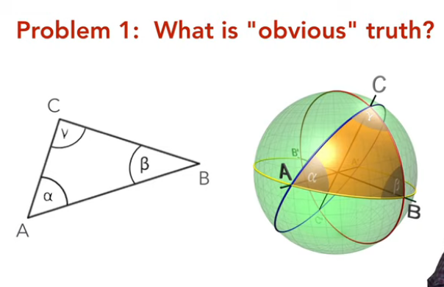
Can every mathematical theorem be derived from a set of agreed upon axioms.
(python function → c code → assemble code → machine code) Machine code is axiom. Can we say same for math. No because Fifth euclidean axiom is not truth for okrugle spere. Context is important (environment).
Infinity
- infinitely large (transfinite numbers)
- infinitely small (infinitesimals) numbers
Russell’s paradox – a naive definition of a set breaks mathematics.
Find mathematical model for mathematical reasoning in real world.
From history
- Aristotel – idea of logic (deductive reasoning)
- Euclid – mathematical incarnation of Aristotel logic
- Gottfried Leibniz – algebra/calculus for logic (computational propositional logic)
- Geroge Boole - propositional calculus
- Georg Cantor – infinity set theory
- Gottlob Frege – First Order Logic (framework) → axioms for set theory → read his books
- Bertrand Russell, Whitehead – Principles of mathematical
- David Hilbert – Hilbert’s program (system) → deductive calculus + deduction rules
- Kurt Godel – Completeness theorem, Incompleteness theorem
- Alan Turing – definition of algorithm
You can rigorously formalize mathematical proofs. There are limits to what can be proved. Computers elevate the significance of formal proofs.
Formally proved theorems
- Fundamental theorem of calculus (Harrison)
- Fundamental theorem of algebra (Milewski)
- Prime Number theorem (Avigad)
- Godel incompleteness theorem (Shankar)
- jordan curve theorems (Hales)
- brouwer fixed point theorem (Harrison)
- four color theorem (Gonthier)
- feit – thomposon therorem (Gonthire)
- kepler conjecure (Hales)

Strings and Encodings
TODO
- https://www.tutorialspoint.com/security_testing/encoding_and_decoding
- https://www.geeksforgeeks.org/what-is-character-encoding-system/
- http://www.steves-internet-guide.com/guide-data-character-encoding/
- https://www.javatpoint.com/types-of-encoding-techniques
How do we mathematically represent data ?
Unit of information - 1 bit (2 states)
Represent data as sequence of strings.
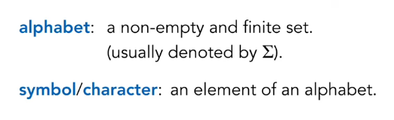
Encoding is a function. For every object (information from real world) you have encoded string. And two object can have the same encoded string. String can and can not be encoding of something. So encoding is injective function.
Does alphabet (list of available characters) affect encodability ? Going from large alphabet to smaller alphabet. We can encode every symbol of large alphabet using t bits where t = [log2k] k- number of letters in larger alpabeth

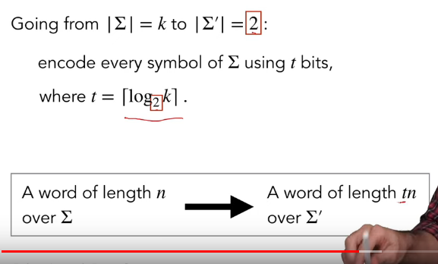
log 2 → because we go to 2 letter alphabet
Encode all symbols using n bits
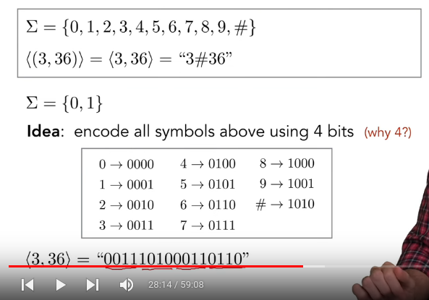

Uncountable sets → approximate

Deterministic Finite Automata

Terminology
computational model – allowed ruled
machine, computer – an instance of computational model
program, algorithm – a specific sequence of information process steps

DFA – deterministic finite automat
input → DFA → output (0 or 1 (reject or accpet))
limited memory
ready input from left to right and accepts or rejects
State diagram example
stao minuta 40 (https://www.youtube.com/watch?v=FmQBWlDMh9A&list=PLKzLTB8HeSUIuln-o1mbXfTr8HmIhiGEg&index=4)
